DSA03-Natural Language Processing
1.Write program demonstrates how to use regular expressions in Python to match and search for patterns in text.
Aim: To write a Python program to match and search for patterns in text using regular expressions.
Procedure:
- Import the re module.
- Define the input text.
- Search for a pattern using re.search().
- Find matching numbers using re.findall().
- Display the output.
Code:
import retext = "My phone number is 9876543210"
result = re.search(r"\d{10}", text)
print("Search result:", result.group())
numbers = re.findall(r"\d+", text)
print("All numbers:", numbers)
Output:
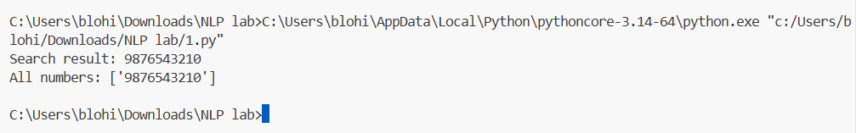
Result: Regular expressions were used successfully to search and match patterns in text.

